SYED RIBAL HASHMI

CMS ID: 4011-2024

AICT LAB ASSIGNMENT #08

**Lab Tasks:**

# QUESTION #01

Add a series of artificial intelligence-themed images to a webpage, using the <img> tag with proper alt text for accessibility. Below each image, include a <h2> heading for the title and a <p> tag for a brief description explaining the image's relevance to AI,

ensuring the content is well aligned and informative.

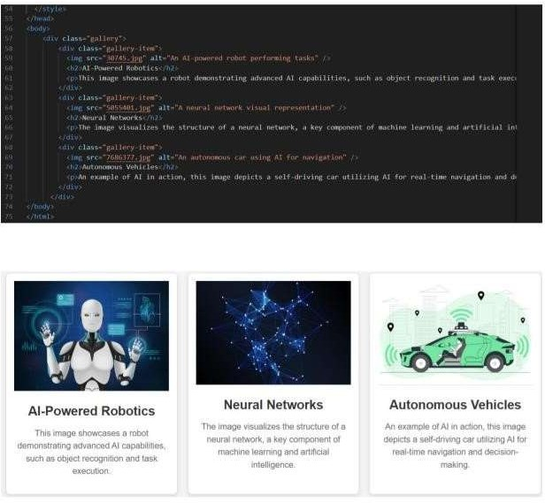

**QUESTION#02**

**Design an HTML table with three columns: Company, Contact, and Country. Each row should display relevant information under these**

**headers using the <tr> and <td> tags. Ensure the table has a border for clarity and includes at least ten rows of data. Below is an example**

**structure:**

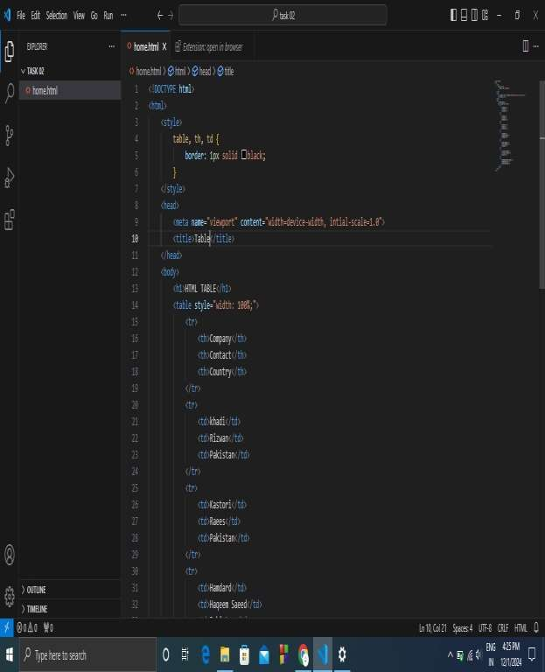

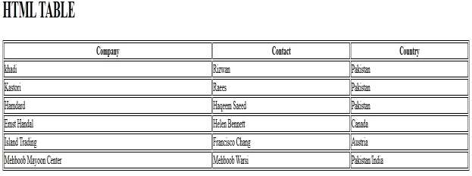

# QUESTION #03

Design a nested ordered list in HTML that includes multiple levels of items. Each list item should be a part of a parent list, with some list items containing their own nested lists. Use the <ol> tag for ordered lists and <li> for list items. Additionally, apply CSS to style the ordered lists by adjusting the font size, list item numbering, and indentation for nested lists. You can also add some padding and color to make the nested list

visually appealing. Below is an example structure.

